**TASK-10**

**EXPLANATION:**

Write a program that simulates a lottery. The program should have an array of five inter named lottery, and should generate a random number in the range of 0 through 9 for each element in the array. The user should enter five digits which should be stored in an integer array named user. The program is to compare the corresponding elements in the two arrays and keep a count of the digits that match. For example, the following shows the lottery array and the user array with sample numbers stored in each.

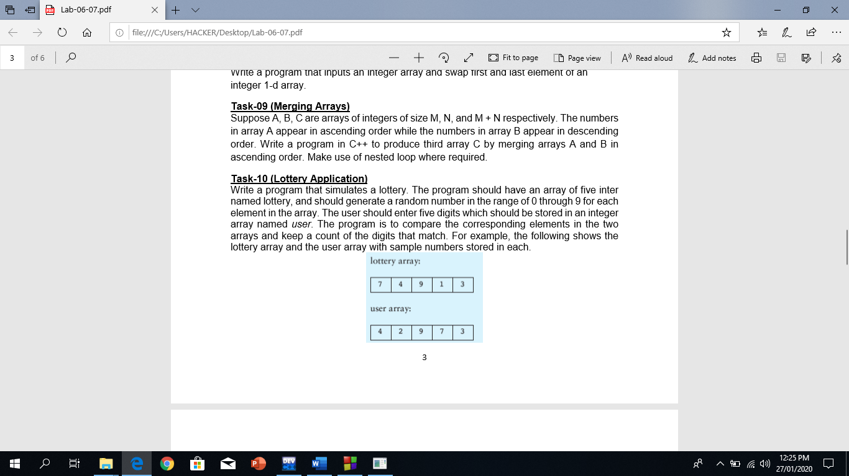

The program should display the random numbers stored in the lottery array and the number of matching digits. If all the digits match display a message proclaiming the user as a grand prize winner.

**INPUT:**

#include <iostream>

#include <stdlib.h>

#include <time.h>

#include "abdullah"

using namespace std ;

int main ()

{

bool flag = true ;

while ( flag )

{

srand ( time (0) ) ;

int lottery_array [5] = {0} ;

for ( int i = 0 ; i < 5 ; i++ )

{

lottery_array [i] = rand() % 10 ;

}

int user_array [5] = {0} ;

int result_array [5] = {0} ;

int x = 0 ;

for ( int i = 0 ; i < 5 ; i++ )

{

cout << "Please enter integer at index A." << i << " : " ;

while ( ! ( cin >> user_array[i] ) )

{

cin_clear ("No character!!") ;

cout << "Please enter integer at index A." << i << " : " ;

}

if ( lottery_array [i] == user_array [i] )

{

result_array[x] = user_array[i] ;

x++ ;

}

}

system("cls") ;

cout << "The lottery is : " << endl ;

for ( int i = 0 ; i < 5 ; i++ )

{

cout << lottery_array[i] << "\t" ;

}

cout << endl ;

cout << "The value entered by user is : " << endl ;

for ( int i = 0 ; i < 5 ; i++ )

{

cout << user_array[i] << "\t" ;

}

cout << endl ;

if ( x == 0 )

cout << "No matching numbers!!" ;

else

{

cout << "The number" ;

if ( x > 1 )

cout << "s" ;

cout << " matching the lottery " ;

( x > 1 ) ? cout << " are" : cout << " is" ;

cout << endl ;

for ( int i = 0 ; i < x ; i++ )

cout << result_array [i] << "\t" ;

if ( x == 5 )

cout << "CONGRAGULATIONS!! YOU WON A GRAND PRIZE!!" ;

}

flag = continuationLoop () ;

}

}

**OUTPUT:**

